NURSERY READING SCHEME OF WORK TERM III
WK | PD | L/AREA | L/OUTCOME | COMPETENCE | CONTENT | ACTIVITIES | SKILLS | L/AIDS | REF | REM
1 | 1 upto 4 | Developing and using my language appropriately | Reading to enjoy, acquire knowledge and understanding | Recognizes similarities and differences in objects,  pictures and letter shapes | Revision of the first 5 trays of Jolly Phonics. S, a, t, p,I, n, ck, e, h, r, m, d, g, o, u, I, f, b, ai, j, oa, ie, ee, or, z, w, ng, v, oo, oo | -Reading all the learnt sounds.  -Relating sounds to their pictures orally.  -Identifying a picture for a sound eg  b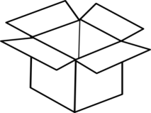  -Drawing pictures for the given sounds.  -Naming pictures using the learnt sounds.  ___ ___ ___  __ ___ __  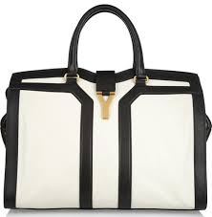 __ ___ ___ | -Fluency  Confidency  Critical thinking. | Wall charts  Flash cards  Individual cards | Finger phonic book
2 | 1 to 4 | Developing and using my language appropriately | Reading to enjoy, acquire knowledge and understanding. | Recognizes similarities and differences in objects, pictures and letter shapes. | Introducing letter sound y and x. | -Listening to the story line of letter sound y and x  -Saying the sounds and their actions.  -Writing sound y and x.  -Sorting sound y and x from other sounds.  -Reading words of sound y and x like yam, yes, yellow, box, fox, axe, six, etc  -Making sentences using the learnt words.eg  It is an axe.  It is a box | -Fluency  Confidency  Critical thinking. | Wall charts  Flash cards  Jolly  Phonics word book pg 10 | Finger phonic book.  Jolly Phonics word book pg 10
3 | 1 to 4 | Developing and using my language appropriately | Reading to enjoy, acquire knowledge and understanding. | Recognizes similarities and differences in objects, pictures and letter shapes | Introducing letter sound ch and sh. | -Listening to the story line of letter sound ch and sh  -Saying the sounds and their actions.  -Blending and reading words of ch and sh eg chair, shop, sheep, ship, chips, chin, chick, church, chest, bench, sheet, shorts, sheet, bench etc  -Writing sound ch and sh.  - Drawing pictures of ch and sh.  - Matching words to pictures. | -Fluency  Confidency  Critical thinking. | Wall charts  Flash cards  Jolly  Phonics word book pg 15 and 15 | Finger phonic book.  Jolly Phonics word book pg 10
4 | 1 upto4 | Developing and using my language appropriately | Reading to enjoy, acquire knowledge and understanding. | Recognizes similarities and differences in objects, pictures and letter shapes | Introducing letter sound th and th | Listening to the story line of letter sound th and th  -Saying the sounds and their actions.  -Blending and reading words of th and th eg these, those, this, they, with, thin, thorn, cloth, three.  - Writing sound th.  - Filling in the missing sounds  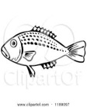 fi ___  _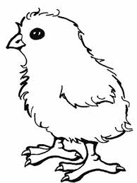___ ___ ck  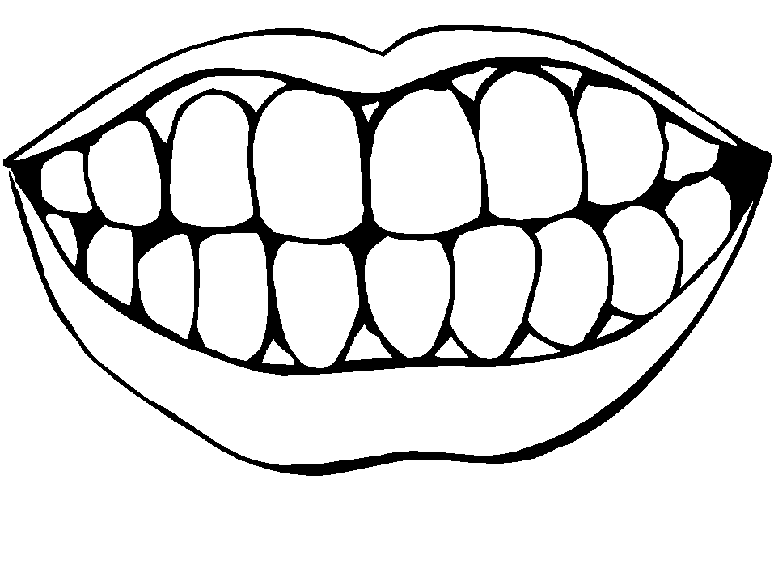 tee ___ | -Fluency  Confidency  Creative thinking. | Wall charts  Flash cards  Jolly  Phonics word book pg 17 | Finger phonic book 6  Jolly Phonics word book pg 17
5 | 1 to 4 | Developing and using my language appropriately | Reading to enjoy, acquire knowledge and understanding. | Recognizes similarities and differences in objects, pictures and letter shapes | Revision of sounds from the first up to the 6th tray.  Naming pictures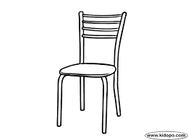 | Blending to form words from the learnt sounds eg sheep , chick , sick, hot foot, sky, tap, black, fork, king, tent, pot, fan etc  -Naming pictures like,  __ __ __  __ __ __  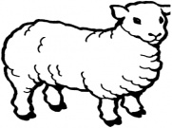 __ __ __  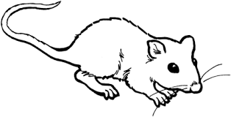___ __ __  ___ ___ ___  -Listen and write words like, fish, chick, pot, van, tin, moon, ten, flag, tree, mat  -Read and draw the pictures like,  It is a cat.  It is a fish.  It is a fan.  It is a van.  It is a chick. | -Fluency  Confidency  Creative thinking. | Wall charts  Flash cards  Jolly  Phonics book | Jolly Phonics word book
6 | 1 upto 4 | Developing and using my language appropriately | Reading to enjoy, acquire knowledge and understanding. | Recognizes similarities and differences in objects, pictures and letter shapes | Introducing letter sound qu and ou | -Listening to the story line of letter sound ch and sh  -Saying the sounds and their actions.  -Blending and reading words of qu and ou eg queen, quill, quilt, quiz, quit  Ouch, out, mouth, house, sound, count etc  - Writing sound qu and ou  - Naming the pictures.eg  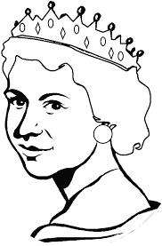  ________ ___________ | -Fluency  Confidency  Creative thinking.  Discovery. | Wall charts  Flash cards  Jolly  Phonics book | Jolly Phonics word book pg 18 and 44
7 | 1 to 8 | Developing and using my language appropriately | Reading to enjoy, acquire knowledge and understanding. | Recognizes similarities and differences in objects, pictures and letter shapes | Introducing letter sound oi and ue. | -Listening to the story line of sound oi and ue.  -Saying the sounds with their actions.  -Reading words of oi and ue like oil, boil, soil, coil, point, join,  Due, glue, sue, value, hue.  - Writing sound oi and ue  - Read and draw ( Phrases)  - Revision of all the learnt sounds and words eg cat, cloud, chain, feet, coin, queen, boat, tie, sound. | -Fluency  Confidency  Creative thinking.  Discovery. | Jolly  Phonics book 7 | Jolly Phonics word book pg 42 and 30  Oxford Primary English book pg 20 and 21 ( phrases)
8 | 1 upto4 | Developing and using my language appropriately | Reading to enjoy, acquire knowledge and understanding. | Recognizes similarities and differences in objects, pictures and letter shapes | Introducing letter sound er and ar | - Listening to the story line of sound er and ar.  - Saying the sounds with their actions.  - Blending and reading words of er and ar like her, sister, brother, silver, number  Car, arm, art, star, smart  -Match words to pictures eg  Cup 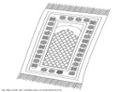  Mat  Book   -Listen and write sounds eg y, x, ch, sh, th, qu, ou, oi, ue, er, ar | -Fluency  Confidency  Creative thinking.  Discovery. | Jolly  Phonics word book pg 34 and 41  Read and see (ar and er words) | Jolly Phonics word book
9 | 1 upto 4 | Developing and using my language appropriately | Reading to enjoy, acquire knowledge and understanding. | Recognises similarities and differences in objects, pictures and letter shapes. | Revision of all the learnt sounds and words. | -Reading learnt sounds and words eg goat, fork, teeth, foot, feet, stool, spoon, box, pail, tail, oil, coin, soil, sheep, car, her, axe, arm, apple, vest, dress, shorts, shirt, horn, blue, green (orally)  Forming sentences using Here is   Here is a ball.  The ball is on the chair.  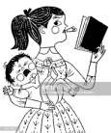  She has a book.  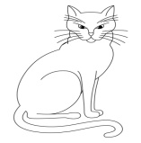 Here is a cat.  -Forming sentences using It is a   It is a hut.  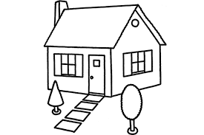 It is a house.  -Reading sentences eg  I am a big girl.  Jane has a red bag,  Peter is a good boy. | Fluency  Creative thinking  Discovery | A chart  Flash cards  Jolly Phonics word book. | Oxford Primary English book.
10 | 1  upto4 | Developing and using my language appropriately | Reading to enjoy, acquire knowledge and understanding. | Recognises similarities and differences in objects, pictures and letter shapes. | Revision of the learnt sounds and words. | -Read and draw eg  I can see a cat.  I can see a spoon.  I can see a ball.  I can see a train.  -Listen and write simple words eg  Boy, flag, green, tap, dish, book, axe, chair, fish, thin  -Read, match and write the words.  Hen _______  Book  Chair _____  teeth 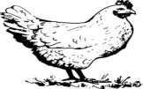______  Coat  ____  -Complete the sentences eg  He has a _________  A ______has two legs.  The 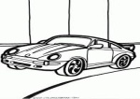_____ is on the road.  A ___ has green leaves. | Fluency  Confidency  Critical thinking | A chart  Jolly Phonics word book

